Choosing the Correct Diverter for Your Installation

Benefits of Diverters:
• More professional & attractive than aluminum
• No more cutting & bending
• Consistent installation
• Made of head resistant PVC
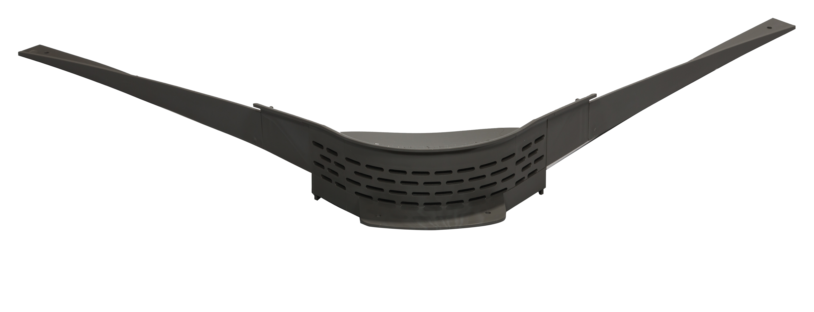
• Eliminate the installation guesswork

The B-1 (recessed mount) Diverter
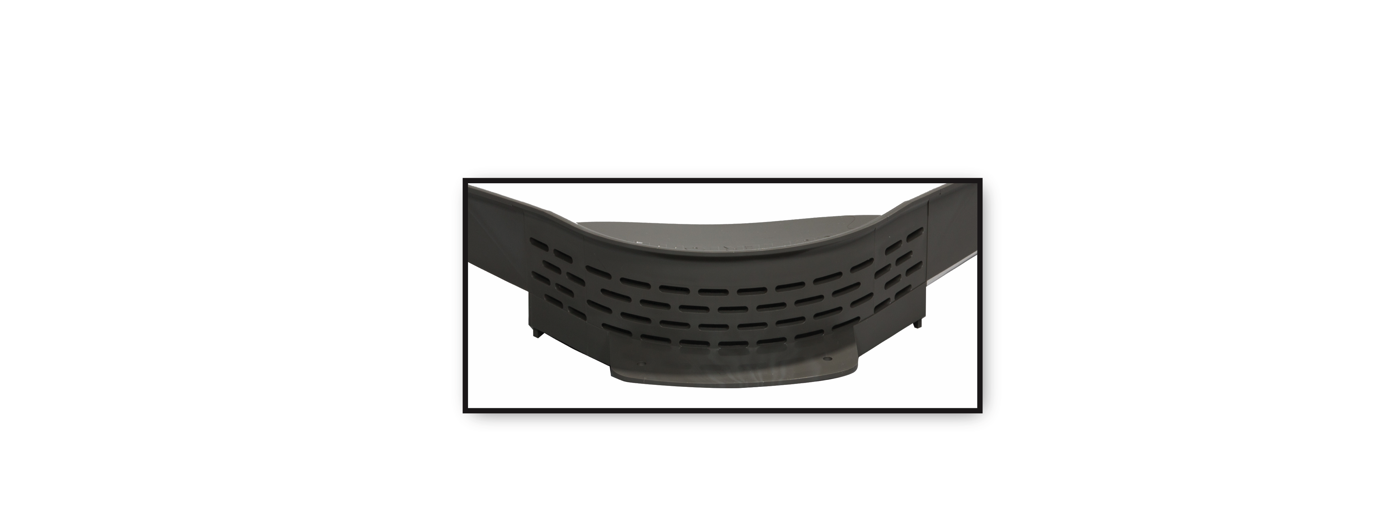
• For Gutter Topper® product inside miter
• Use on homes with an 8-12 to 15-12 pitch
• Patented reversed curve that creates a churning action
Which helps prevent the debris build-up
• Recesses into the Gutter Topper® allowing more water
To go into gutter instead of over it closeup: back of diverter
• The B-1 reduces large amounts of water that may jump
Over the standard diverter.

The B-2 (surface mount) Diverter
• Use on homes with a 3-12 pitch to a 7-12 pitch
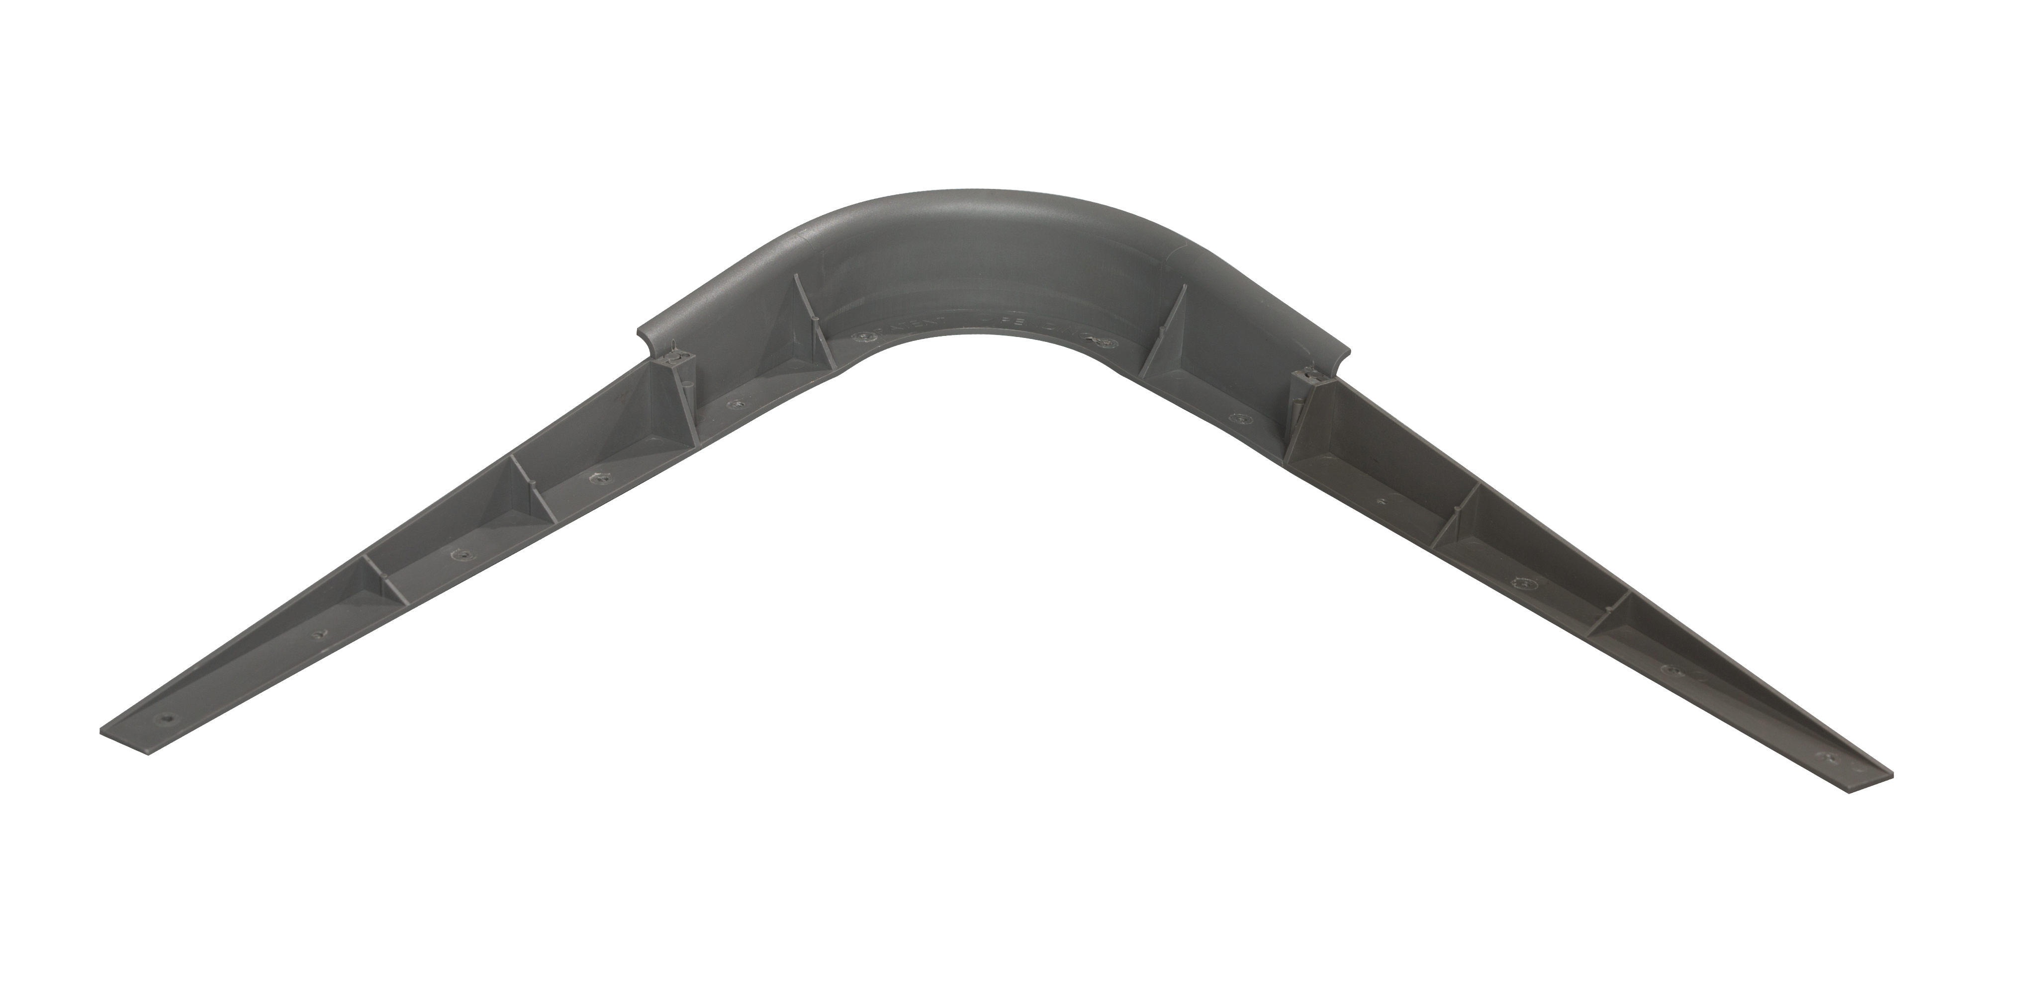
• 1 ¾”, a full inch longer than the current diverters
• Has lip to prevent over-flow
• Professional appearance on the home
• Tapered extension reduces water over-flow at valleys
• Tapered extensions are flexible for uneven miters
• Interchangeable tapered extensions

B-2 Diverter can alo be use on our family of products.
On top of Inside miters on Terminator, Needle guard, and Solution.

Available in the folloing colors, Black, Bronze, Royal Brown, Charcoal, and Light Gray.

