Installation of Inside Miter is quick and easy with Gutter Topper®

Mark the gutter cover where the front side of the opposite gutter
intersects Standard Gutter Topper®, this is typically four (4) inches
on a 5K gutter and five (5) inches on a 6K gutter.

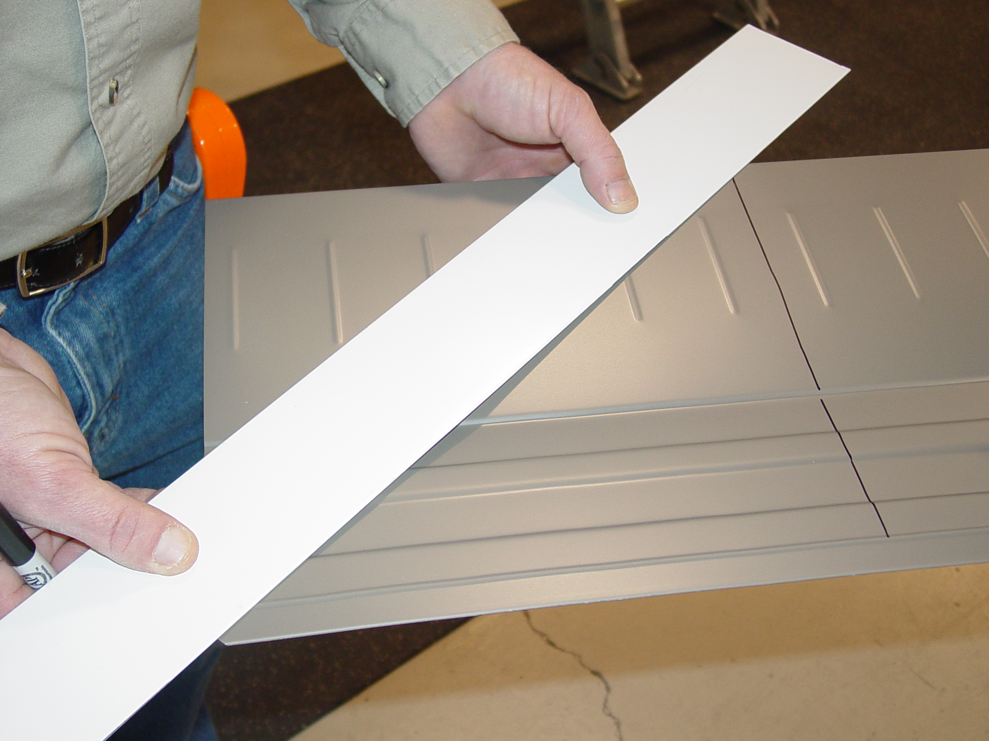 (Figure 1) 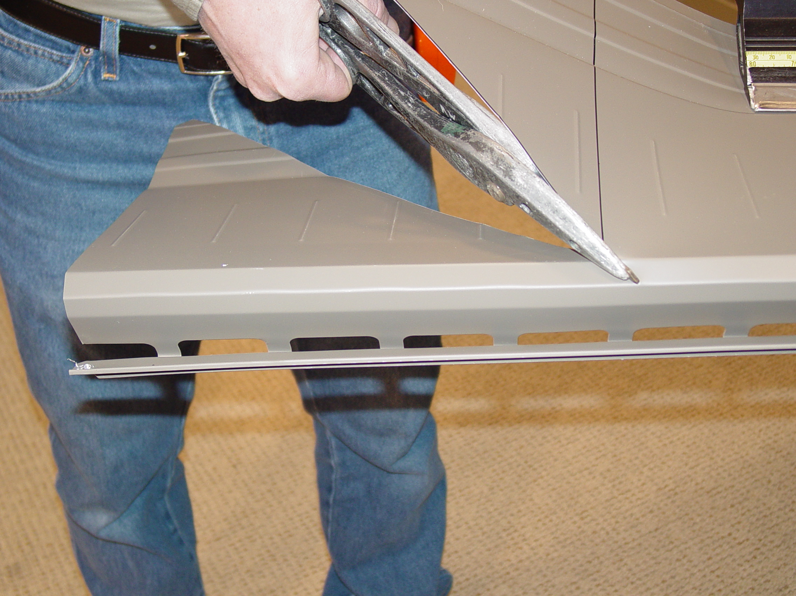 (Figure 2)

1. Make a 45° cut using tin snips from the mark to the back of the
Gutter Topper®. Then cut from the back to the front lip of the Gutter Topper® an
additional one inch from the corner (Figure 2).

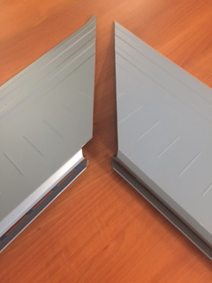 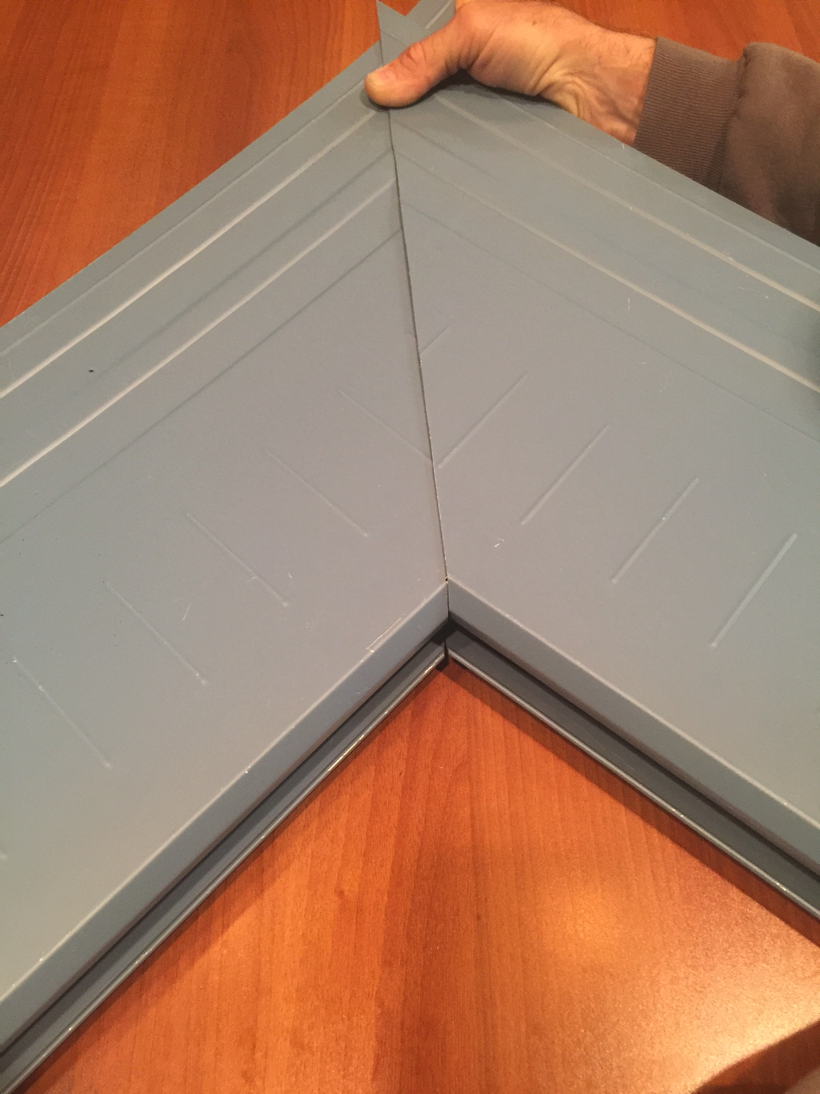 (Figure 3)
inside miter side by side inside miter pieces together

2. Install the two corners’ pieces with one (1) inch overlap. A screw
in the back flange of the lower piece may be necessary to support
the corner. A screw should be placed in the lip of the Gutter Topper
approximately one (1) inch from the inside corner to fasten the
corner to the gutter. Put 2 or 3 zip screws through the flat area to complete the simple corner installation.
important Note: In high flow areas, a B-1 diverter, or B-2 Diverter may be necessary to prevent overflows.

Installation of Outside Miter
1. Measure and mark a 45° angle from the outside edge of the front
of the gutter cover toward the back. Using tin snips, cut
along the line drawn and then cut and remove one (1) inch of the
vertical ledge

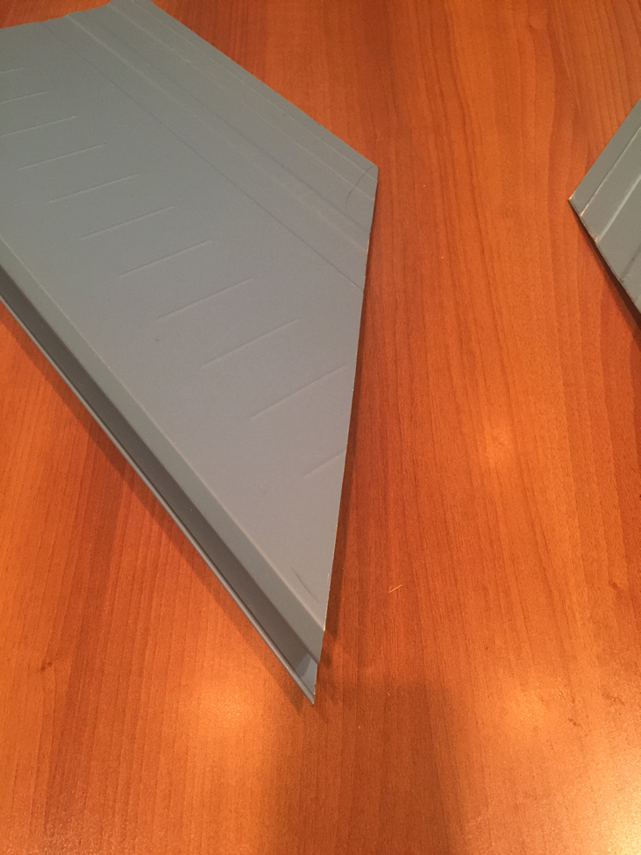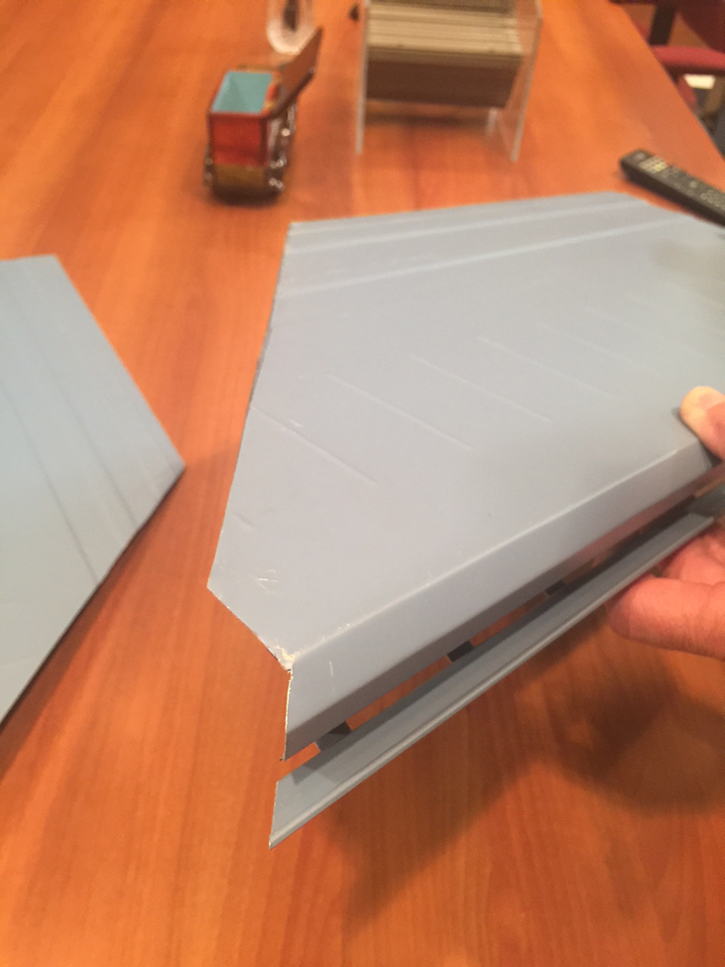
(Outside miter 45° cut) (Outside miter front view)

2. When installed, a 1" overlap should exist. Place screws one
(1) inch from the end to secure the Gutter Topper®, as well as one screw
through the overlap
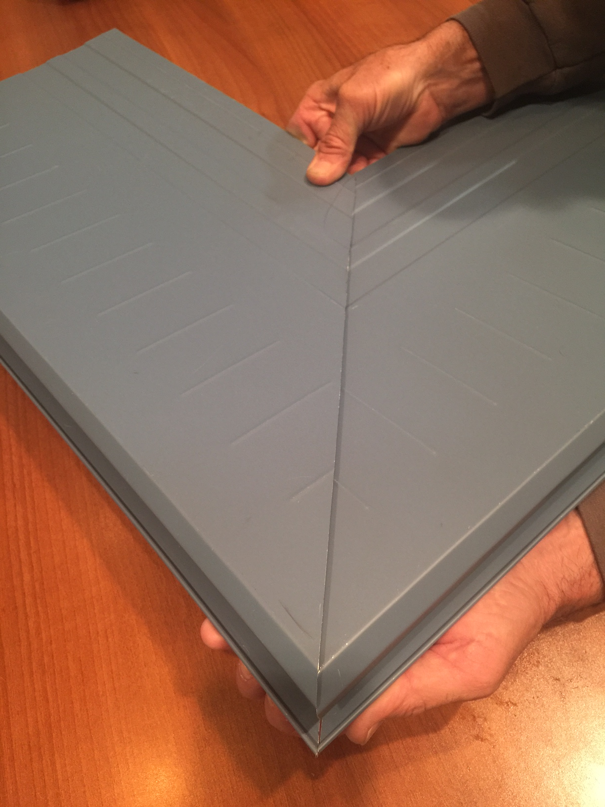
(Outside miter front view)

